PROJECT DEMONSTRATION PHASE
INTRODUCTION
PROJECT TITLE:
AI Blog Nest API – An Intelligent Backend for Blog Operations
TEAM ID : SWTID-2026-6013
TEAM LEADER : MADHUMITHA.J
TEAM MEMBERS :
MADHUMITHA.J
SHALINI.G
SIVATMIKA ANAND
JAINA.S
Blog Nest is an AI-powered blogging backend system built using Node.js and Express.js. The application offers APIs for user authentication, profile handling, blog creation and management, along with AI-driven features for content generation and summarization.
The project was designed, implemented, and tested with the help of Visual Studio Code, Postman, MongoDB, and the Google Gemini API.
The primary objective of this demonstration is to present the backend workflow, explain how the APIs are created and tested, demonstrate how information is stored and managed in MongoDB, and showcase the integration of AI capabilities within the application.
Technologies Used
The following technologies and tools were utilized for developing and testing the project:
The following technologies and tools were utilized for developing and testing the project:
● Node.js – Server-side runtime environment
● Express.js – Framework for building backend APIs
● MongoDB – NoSQL database for storing application data
● Mongoose – Library for database connectivity and schema management
● JWT – Token-based authentication and user authorization
● bcryptjs – Secure password encryption and hashing
● Google Gemini API – AI-powered content creation and text summarization
● Postman – Tool for creating and testing API requests
● Visual Studio Code – Code editing and project development environment
● Nodemon – Development utility for automatically restarting the server

Project Development Environment
The project was created and implemented using Visual Studio Code.
The application is organized into multiple folders and files that manage routes, controllers, middleware, models, configuration settings, and server-related operations.
This organized structure makes the backend easier to understand, maintain, and develop by keeping each functionality separated into its respective section.
[VS Code Project Folder Structure]
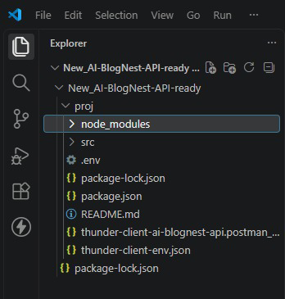
Backend Server Initialization
The backend application is launched using Node.js along with Nodemon for development.
Once the application is started, the server operates on port 5000.
The required environment settings are initialized, and the application connects to the MongoDB database to store and retrieve project data.
[ VS Code Terminal Showing Server Running]
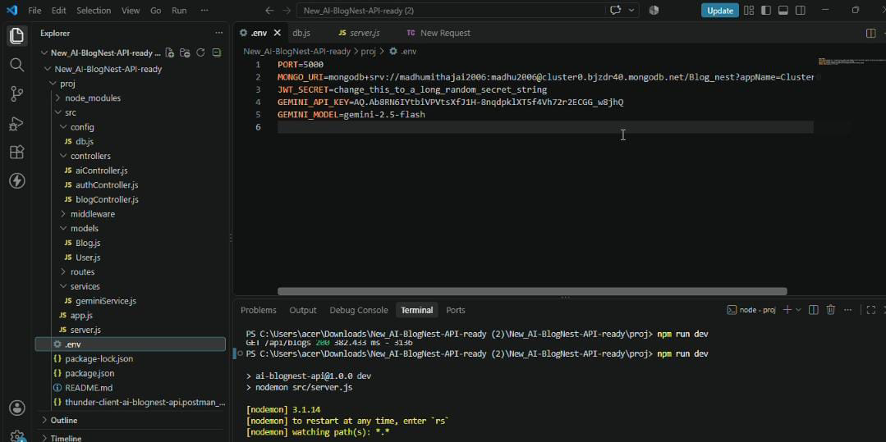
MongoDB Database Connection
MongoDB is used as the primary database for the Blog Nest application.
The backend uses Mongoose to establish a connection between the Node.js application and MongoDB.
MongoDB maintains data such as:
● User information
● Login and authentication details
● Blog-related data
● Blog title and category
● Blog content and descriptions
● Creation and modification timestamps
The database connection enables the application to save, access, and update required information whenever an API request is processed.

[ MongoDB Database/Collection Screenshot]
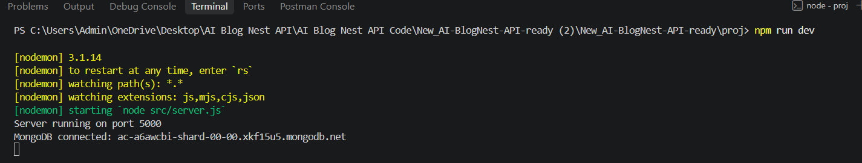
API Testing Using Postman
Postman is used to test and showcase the various REST API endpoints available in the Blog Nest application.
The API requests are made to the local backend server operating on port 5000.
The main API functionalities demonstrated are:
● User account registration
● User authentication and login
● Creating a new blog
● Retrieving blog details
● Generating blog content using AI
● Summarizing blog content using AI

User Registration
The initial step involves creating a new user account through the registration API.
The registration endpoint receives essential user details such as:
● Name
● Email address
● Password
The provided password is securely encrypted before it is saved in the database.
Once the registration process is completed successfully, the API sends a confirmation response.

[Postman Registration Request and Response]
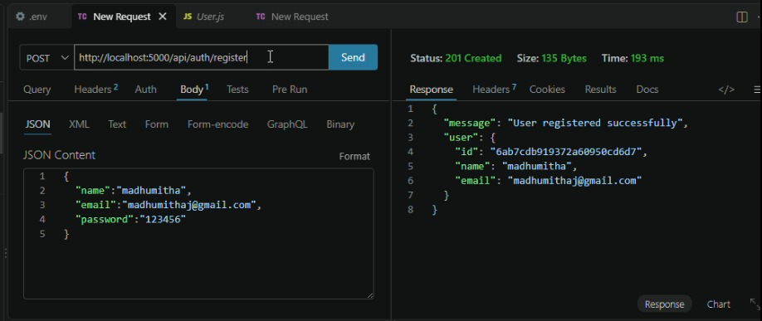
User Login
After completing the registration process, the user can sign in using the registered email address and password.
When the login credentials are verified successfully, the backend creates a JWT authentication token.
This token is used to authenticate the user and access protected API endpoints.
[Postman Login Request and JWT Response]
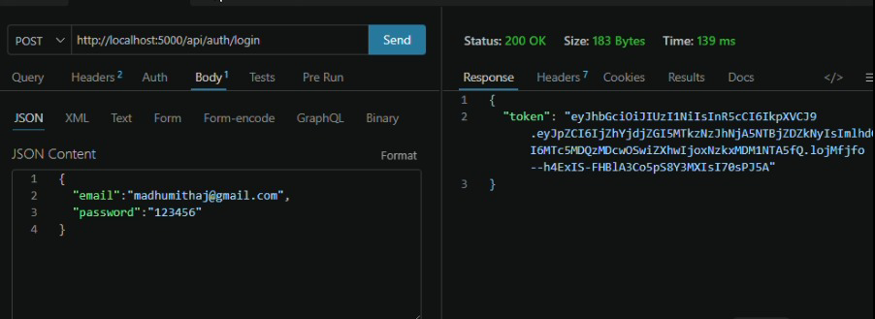
Creating a Blog
A new blog post can be added by sending a request with information such as:
● Blog title
● Blog category
● Blog content
The request is verified using the JWT authentication token.
Once the blog is created successfully, its details are saved in MongoDB and the API provides the newly created blog information in the response.
[ Create Blog API in Postman]
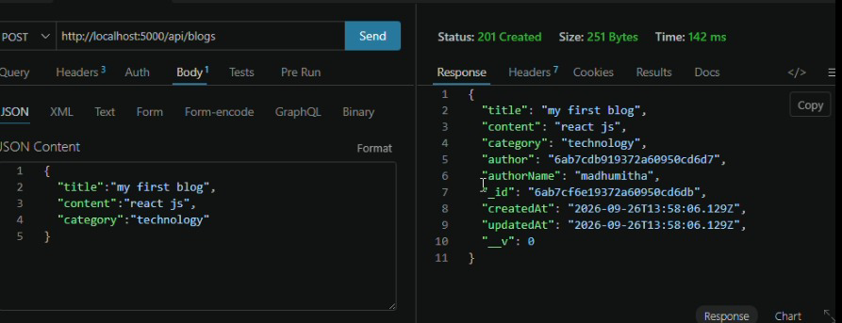

Fetch Blogs
The application includes an API for retrieving the existing blog posts.
The API obtains the saved blog data from MongoDB and returns the available blog records in the response.
[Fetch Blogs API Response]
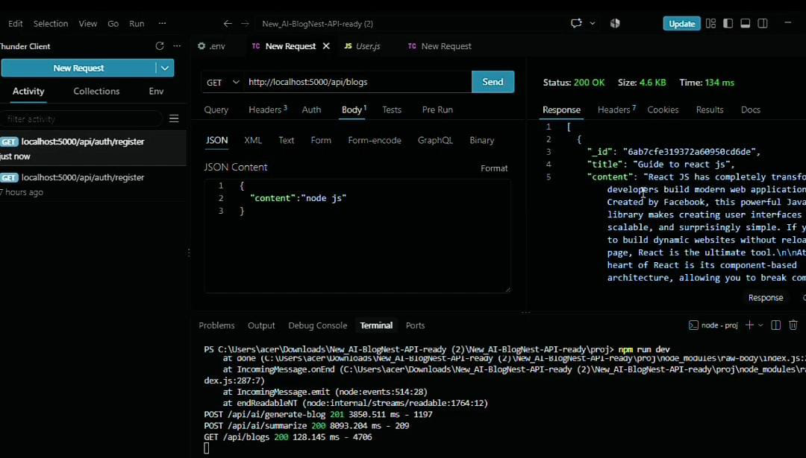

AI-Blog Generation
One of the key features of Blog Nest is its AI-based blog content generation functionality.
The application uses the Google Gemini API to create blog content based on the information provided by the user.
The user enters details such as:
● Topic
● Category
The backend forwards these details to Gemini, which generates suitable blog content based on the given input.
The generated content can then be reviewed, modified, and used as a foundation for creating a new blog post.
[Generate Blog API Request and Response]
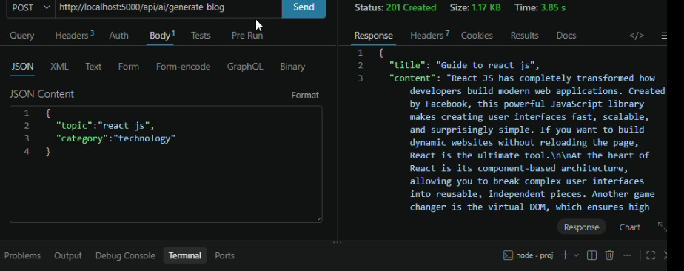

AI-Powered Blog Summarization
Blog Nest also includes an AI-based summarization functionality.
The summarization API receives the blog content and sends it to Google Gemini for processing.
The AI analyzes the given content and produces a concise summary that is easier to read and understand.
This feature helps users get the main points of lengthy blog content without having to read the entire text.
[ Summarization API Request and Response] 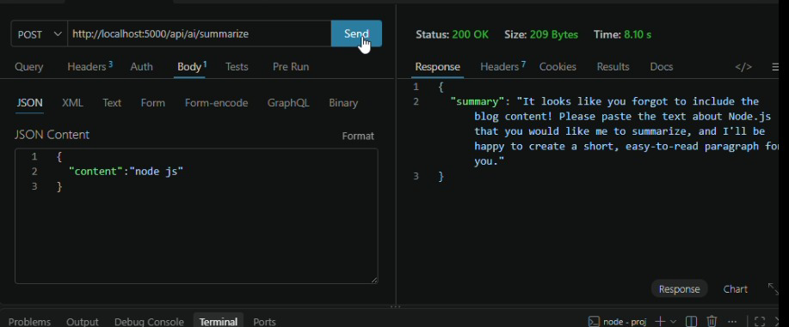

Complete Project Demonstration Flow
The overall demonstration of Blog Nest follows the sequence below:
Start Server → Establish MongoDB Connection → Register User → User Login → Generate JWT Token → Access Secure APIs → Create Blog → Retrieve Blog → Generate AI Content → Summarize Blog
This workflow illustrates how the various modules and features of the application interact with each other.
Demonstration Summary
The Project Demonstration Phase highlights the functional implementation of Blog Nest.
The application demonstrates backend development with Node.js and Express.js, data storage and management through MongoDB, API verification using Postman, user authentication with JWT, and AI-powered blog generation and summarization through Google Gemini.
The demonstration gives an overall understanding of how these technologies are integrated to build and operate an AI-enabled blogging backend system.
Demo Video : https://drive.google.com/file/d/1EuAr91UzdqlgXt0jctYAKIe0eKfpecTD/view?usp=drivesdk

